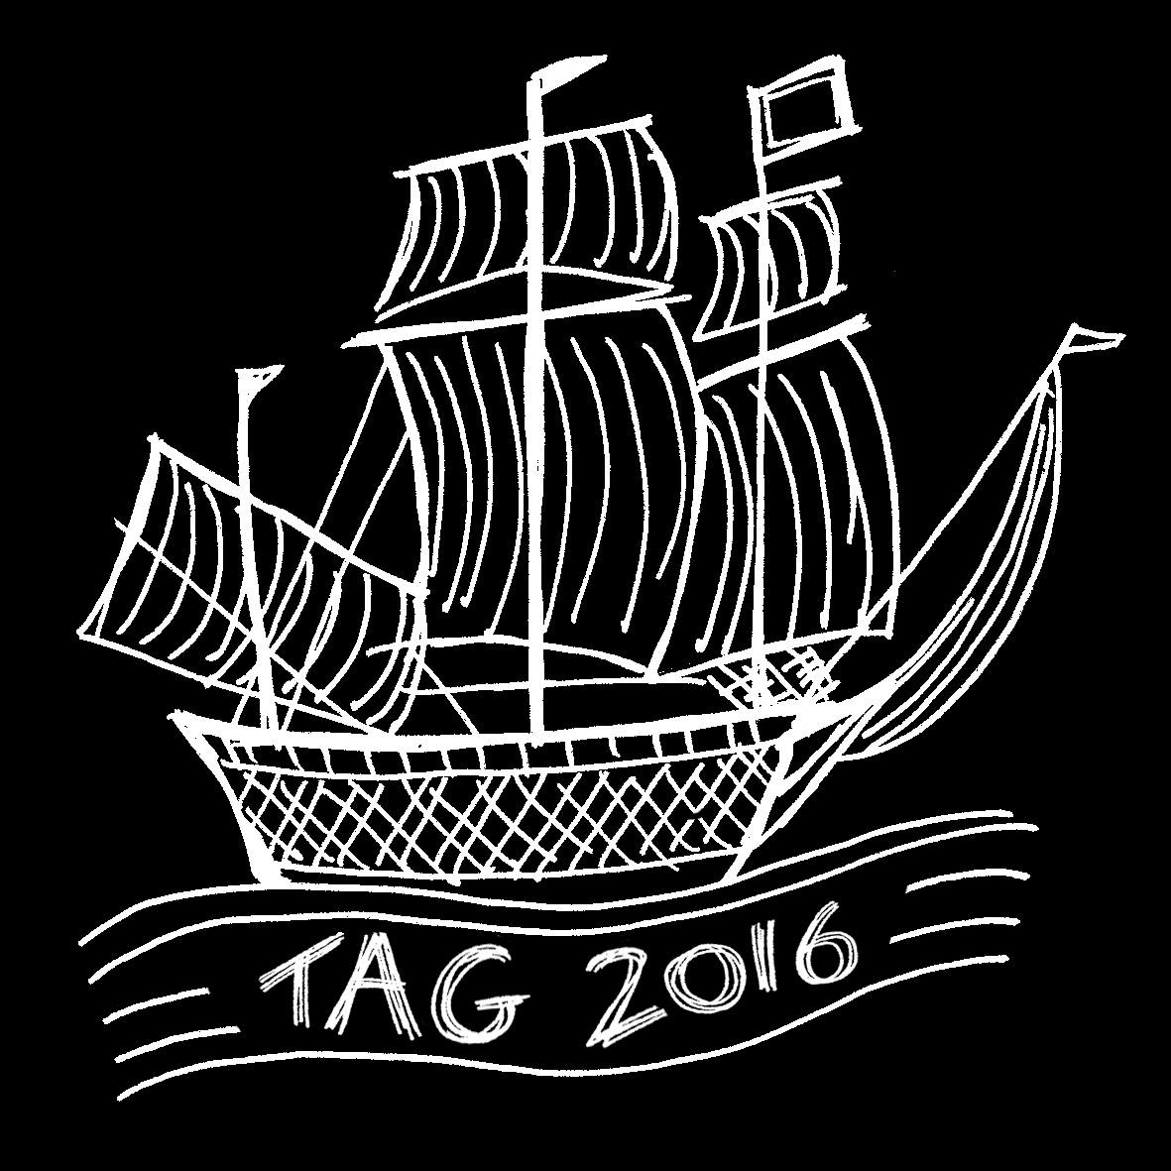

APPLICATION TO CONTRIBUTE TO SIGHTATIONS EXHIBIT, TAG 2016 SOUTHAMPTON

Please submit your application or direct any queries to info@artasmedia.com. Deadline for applications is 31st October 2016.

Title: …………… First name: …………………………………………

Surname: ………………………………………………………………..

Phone: ……………………………………………………………………

Email: …………………………………………………………………….

Twitter: …………………………………………………………………..

Affiliations:………………………………………………………………

Title of Work: ………………………………………………………….

Year: …………………………

Please attach:
- A short abstract explaining the work and how it relates to Sightations aims and visualisation theme (2 pages max)
- A photograph or screenshot of the work

Medium(s) (eg. painting, pencil, ink, paper, canvas, ceramic, textiles, photography, sculpture, wood-work, metal-work, CGI display, VR display, digital film, video, online platform, phone app, performance art, mixed materials, etc. If digital please include specifications eg. file type, size and display ratio):

…………………………………………………………………………..…

……………………………………………………………………………..

Physical Dimensions (if relevant): ………………………………..

Duration (if relevant): ………………………………………………….

Resources you will need (eg. PC display, projector, ipad, headphones, speakers, estimated space required, wall space, electricity, etc):

……………………………………………………………………………

……………………………………………………………………………

……………………………………………………………………………

……………………………………………………………………………

Sales:
The sale of works is to be arranged privately between contributors and gallery visitors. If you would like to sell your work please advise us and we will include your contact details in the exhibition catalogue.

My work is for sale: Yes ☐ No ☐

Sales contact details: ……………………………………………….

……………………………………………………………………………

I confirm that all work submitted is original and my own: ☐

OR

I am authorized to apply on behalf of my organization/business: ☐

Signature: …..……………………………… Date: …………………

