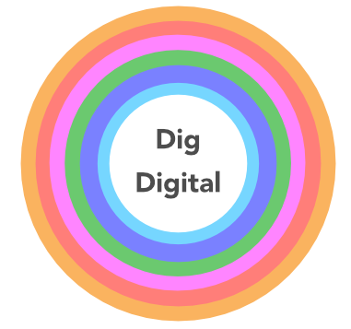  Digital health check questionnaire and action plan |  |  | Actions
areasHealth check question |  | Yes / No | What? | Who? | When?
Standards | Are you familiar with FAIR Principles and CIfA Standards, in relation to data in archaeology projects?
 | Do you frequently review relevant data standards and update methodology?
Planning | Do you use a data management plan for all projects? If yes, is your standard DMP consistent with the Dig Digital DMP template?
 | Do you normally contact the intended trusted digital repository during planning stages to review guidelines, discuss requirements and estimate costs?
 | Do you have an archive review process at key stages of project delivery, which includes updating the DMP and selection toolkit?
Document | Do you set up and update an OASIS record (or equivalent) for each project?
 | Do you have a process and templates for collection of metadata which aligns with the digital repository?
 | Do you have a GDPR compliant Privacy Policy which considers management of digital personal data?
 | Do you have appropriate data-sharing agreements in place with third parties, and processes which record data sharing restrictions for archive access?
Structure | Do you use a consistent folder structure for the storage of digital project files?
 | Do you manage and monitor naming and version control of files and documents?
 | Do you ensure that data is stored in an accessible place as part of the working project archive and includes external specialist data?
 | Do you maintain a security copy and backup of your digital data?
Process | Do you have clear roles and responsibilities for project staff (including subcontractors) with regards to digital data and metadata (including ethical/legal compliance)?
 | Are digital processes and conventions documented included in organisational documents, such as manuals or a Data Management Policy?
 | Do you have a selection strategy in place for long-term preservation in each project?
 | Do you have quality assurance processes in place for data collection and management?
Deposition | Do you identify the trusted digital repository at the start of the project and include details in the DMP?
 | Do you review, update and ring-fence budget and resource needs for archive preparation and deposition?
 | Do you check data format and metadata requirements of the digital repository at project planning stage?
 | Do you review the deposition process with the trusted digital repository?

