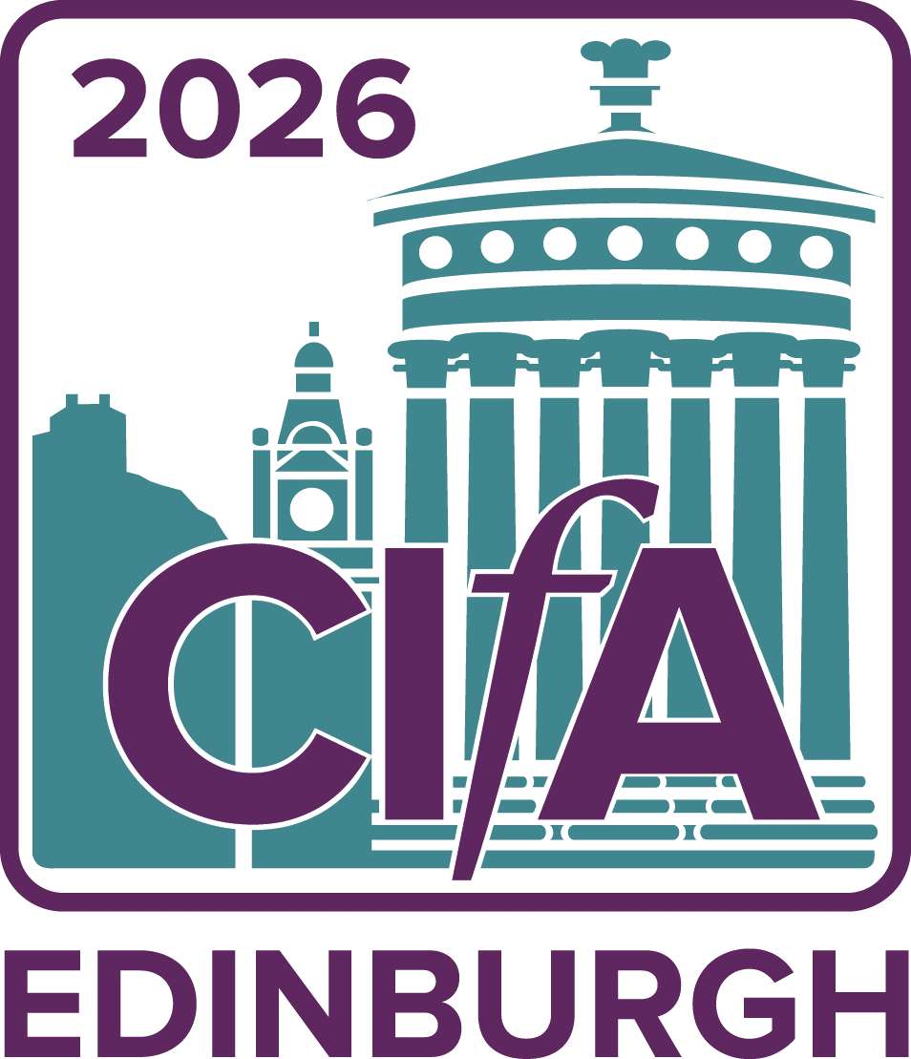
Annual conference
Call for papers

28-29 April 2026

About CIfA2026
CIfA is delighted to announce that the CIfA2026 conference will be hosted from Tuesday 28 April – Wednesday 29 April 2026.

We intend to host CIfA2026 as an in person conference, hosted live in Edinburgh UK with sessions streamed online.

CIfA2026 will incorporate keynote addresses, wide-ranging sessions and training workshops in a live and virtual forum. Across the conference, we will discuss current professional issues, showcase new developments, and present research in archaeology and the wider heritage sector. Our conference is the premier professional archaeological conference in the UK, attracting hundreds of participants across the heritage environment sector.

Draft conference programme with confirmed sessions
The following draft conference programme details the sessions that have been confirmed for CIfA2026.
Call for papers
These sessions are actively accepting and calling for papers and would welcome submissions from individuals, groups or organisations who may be interested in contributing to the session at CIfA2026.
We want these to showcase great archaeology, to stimulate debate, and to look to change how we work and how we promote our profession to others.
We intend to record all presentations (barring a few exceptions) delivered at CIfA2026 and to livestream presentations delivered in person. All session recordings will be made available for our attendees to view on demand from our online conference platform.

Each session is provided two complimentary places at conference. These are generally reserved for session organisers for the time invested. Beyond those two places, speakers will be asked to pay £60 for the day they are speaking. This is to cover costs. If this fee is prohibitive for your attendance, there will be several bursaries available, including a speaker-specific bursary pool, which can assist with registration costs, travel costs, or care costs. Your ability to cover these costs will not impact paper selection.

To submit a proposal for a paper:
- Email the session organiser directly, as indicated on their session below
  - Include the title of your paper and an abstract of up to 150 words
  - make sure you include your name and contact details in your submission
  - advise if you have any additional requirements, needs, or may need any logistical support
  - confirm your availability to attend in person on the date/time of the session as per our draft timetable

In the interest of promoting a more varied set of speakers, this year we will ask speakers to present papers at a maximum of two sessions. If you are offered the opportunity to speak at three or more sessions, you will need to select two. We hope this will give more opportunities to present for early careers archaeologists and those who may not have been selected to present in previous years.

The deadline for the submission of papers is 6 February 2026.

Conference timetable
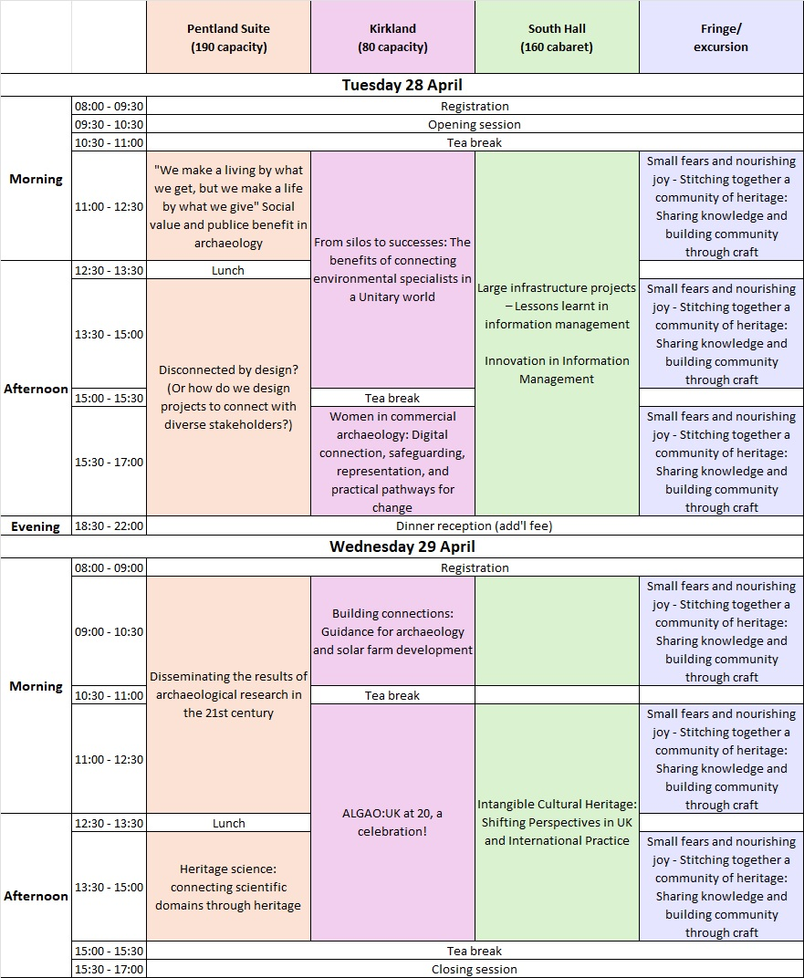
- Tuesday 28 April, 11:00 – 12:30
“We make a living by what we get, but we make a life by what we give” Social Value and Public Benefit in Archaeology
Adam Fraser, Emilia Zelewicz (adam.fraser@arcadis.com, emilia.zelewicz@arcadis.com)
There is an ever-increasing demand to demonstrate value for money. Whilst we recognise that the profession must be profitable to thrive, this session will highlight projects, particularly those originating in commercial or development led archaeology that have made Social Value and Public Benefit a priority. CIfA has long recognised, as heritage professionals we have an ethical commitment to promote the value of the historic environment and to engage with the public, to include, inform and inspire. This session invites papers that have utilised technologies that have deepened our understanding of our shared heritage. Whether this is on the cutting-edge of historical research and interpretation or using traditional methods in new ways, we want this session to shed a light on those in the industry who are ensuring that the public benefits from the work that we do.

- Tuesday 28 April, 13:30 – 17:00
Disconnected by Design? (Or how do we design projects to connect with diverse stakeholders?)
Guillermo Diaz de Liano, Sadie Watson (gdiaz@mola.org.uk, swatson@mola.org.uk)
This session seeks to explore, from a critical yet constructive perspective, the ways in which project design in archaeology affects how we engage with diverse stakeholders. While it is common for a myriad of professionals (developers, heritage specialists, planning authorities, etc) to have a say in how archaeological projects are designed, communities often occupy a passive place, with whom heritage specialists interact through open days and talks showcasing results of excavations, but without granting them any real input in how projects are actually designed. We seek to explore alternative and more radical approaches, where the agency of communities in project design is explored in more depth.
Among the potential topics, the session aims to explore:
• Successful (and unsuccessful!) case studies where innovative ways of project design managed to integrate the communities in the design, delivery or dissemination of archaeological works.
• Critical analysis of how current notions of project design pose problems for the integrating of diverse stakeholders. These can include all sorts of aspects of archaeological work, ranging from the specific way in which we design our interventions, WSIs, Funding bids, Health and Safety regulations, and so on, to the general structural conditions affecting archaeological work, e.g., precarity, underfunding of the sector, etc.
• Constructive proposals on new ways of designing archaeological projects and interventions so they do a better job integrating external stakeholders, which could include communities, academic partners, third sector organisations etc. A speculative and future-oriented focus would be welcome, as one of the keys to do better archaeology is being able to imagine a better way of doing archaeology!

- Tuesday 28 April, 11:00 – 17:00
Future-Proofing Archaeological Data: Lesson Learned, Innovation and Better Practice
Laura O’Connor, Theordora Anastasiadou, Information Management group, Archives group (laura.oconnor@hes.scot, dora2ionta@yahoo.com)
From local community archaeology projects to nationally significant infrastructure schemes like HS2 and A14, the sector relentlessly generates vast amounts of rich and valuable digital data. These digital archives can typically include excavation records, finds databases, environmental datasets, digital images, specialists reports, survey and remote-sensing data, 3D models and GIS layers. Yet we still face challenges in standardising, sharing, curating and accessing that information for future use. How do we move beyond ad hoc or project-specific approaches toward practice that is sustainable, consistent and FAIR-aligned?
This session invites contributions exploring practical experiences and innovative approaches in archaeological information management. Papers may draw on case studies such as citizen science projects, regional research framework programmes, or major infrastructure schemes, with a shared aim of understanding what works, what doesn’t, and how the sector can raise the bar collectively.
We welcome examples ranging from improved workflows and data governance to digital innovation such as linked data, semantic enrichment, automation and AI-assisted processes. The aim of this session is to reflect on the lessons emerging from across the heritage ecosystem - from commercial units, museums, archives, HERs to academic institutions - and to discuss how collaboration and experimentation are transforming how we create, manage, reuse and disseminate archaeological data.
Themes may include:
• Lessons learned from excavation projects - ranging from small scale to large infrastructure - and recommendations for the way forward
• Embedding good data practice early in project design
• Interoperability, standardisation and the realities of sector-wide workflows by data creators and users
• Digital innovation - looking towards linked data, automation & emerging tools
• Long-term archiving (including current issues), sustainability & FAIR principles
• Collaboration across organisations, systems and disciplines

- Tuesday 28 April, 15:30 – 17:00
Women in Commercial Archaeology: Digital Connection, Safeguarding, Representation, and Practical Pathways for Change
Heloise Meziani, Digger’s Forum (cifadiggersforum@gmail.com)
Ten years on from CIfA’s 2015 “glass ceilings” conference, women remain the majority of the UK commercial archaeology workforce, yet leadership, decision-making, and visibility still lag behind. This Digger’s Forum session asks a simple but challenging question: what has actually changed, and how do we change what hasn’t?
We invite contributions that explore women’s lived experiences in commercial archaeology today, focusing on safeguarding, progression, confidence, and connection. The session will bring together research evidence, practitioner insight, and real-world examples of what helps, and what hinders meaningful change.
A particular focus of the session is connection: how women build support networks on site, online, and across organisations; how digital spaces such as social media can both empower and exclude; and how generational differences in communication can shape wellbeing, safety, and belonging in the workplace.
We are especially keen to hear from voices that are often under-represented at conferences, including field archaeologists, supervisors, early-career practitioners, and those who may not see themselves as “academic speakers” but have important experiences to share.
Possible themes include:
•Safeguarding realities for womxn in commercial archaeology and project-based work
•Confidence, credibility, and career progression
•Recruitment practices and structural barriers to leadership
•Women’s experiences of social media, online visibility, and digital community-building
•Generational differences in communication and expectations
•Practical initiatives, formal or informal, that have made a positive difference
•Focus on practical solutions, innovation, looking forward to implementing changes in the industry in the near future.
We welcome a range of formats, including:
•Short papers (12–15 minutes)
•Brief provocations or reflective contributions
•Joint or co-presented papers
•Practitioner-led or lived-experience perspectives
•drawing, cartoons, various formats, etc
The session will be actively chaired and include a facilitated discussion. To support open and sensitive conversation, parts of the discussion may not be recorded; contributors will be informed in advance.
If you are unsure whether your idea fits, or if this would be your first conference presentation, we encourage you to get in touch. This session aims to create a supportive, respectful space for honest discussion and practical thinking about how we improve conditions for womxn working in commercial archaeology.

- Wednesday 29 April, 09:00 – 12:30
Disseminating the Results of Archaeological Research in the 21st Century
Simon Gilmour, Beverley Ballin-Smith (director@socantscot.org, editor@archaeologyreportsonline.com)
With changing funding structures, changing needs and changing audiences, how is archaeological research now disseminated? The Society of Antiquaries of Scotland and GUARD Archaeology Ltd both produce various forms of research output (from videos, comic-style products through to online articles and the national journal for archaeology in Scotland) and are looking to bring together others who both disseminate research and consume it to understand the current situation and potential future(s) for 'publishing' in its widest sense.

- Wednesday 29 April, 11:00 – 15:00
Intangible Cultural Heritage: Shifting Perspectives in UK and International Practice
Leonora O’Brien, Alex Godden (leonora.obrien@atkinsrealis.com, alex.godden@environment-agency.gov.uk)
In March 2024, the UK ratified the UNESCO Convention for the Safeguarding of Intangible Cultural Heritage (ICH), marking a major cultural and policy milestone. This workshop explores how ICH is reshaping archaeology, natural and cultural heritage practice across the UK and globally.
Drawing on case studies and approaches from devolved administrations and international contexts, we’ll examine how living cultural heritage - such as oral traditions and performing arts, rituals, crafts, environmental knowledge and sustainable land-use practices - can be integrated into our work, including inventorying, impact assessment, community engagement, heritage and land management, and sustainable place-making.
Through a mix of short talks followed by discussions and practical exercises, participants will explore the challenges and opportunities of working with dynamic and evolving cultural traditions. Topics will include contested interpretations, inclusive representation, authenticity and reinvention, participatory heritage, the need for new skills and training in archaeology and ethnography, policy gaps, and integration into planning frameworks.
We welcome scene-setting papers from colleagues involved in developing ICH policy and practice across devolved administrations and internationally.

