

Degree Accreditation: Guidance on Making Your Application

Contents
Introduction 2
The Aims of Accreditation 2
Eligibility 2
Cost of Accreditation 2
The Application and Accreditation Process 3
Process and Timeline 3
The Application Form 4
The Mapping Exercises 4
Supporting Documents 6
Site Visit 6
Outcome of Accreditation 7
Publicity and Promotion 8
Benefits for Students 8
Maintaining Accreditation and Re-Accreditation 9
Appendix 1: Summary of Standards to be achieved 10
Mandatory Standards 10
Five most commonly selected Optional Standards 11
Appendix 2: Example Mapping Matrix document 13

Introduction
Accreditation is offered jointly by the Chartered Institute for Archaeologists (CIfA) and the University Archaeology UK group (UAUK). The accreditation procedure is jointly overseen, managed, and endorsed by CIfA and UAUK; with the CIfA Degree Accreditation Committee making the final awards.

The Aims of Accreditation
CIfA wishes to ensure that the sector has access to sufficient skilled, accredited professionals to meet the demand for historic environment services. To this end, CIfA is keen to see the development of a range of flexible entry routes into the profession, which not only provide the skills the sector needs, but also encourage a greater diversity amongst those entering the profession. In this regard, CIfA wants to ensure that academic study is providing appropriate skills that are relevant to a career in the historic environment, and that students have the opportunity and are encouraged to achieve professional accreditation of those skills at the appropriate level.

UAUK wishes to ensure that graduates are equipped for the workplace should they wish to pursue a career in archaeology. The group recognise that accreditation is one way of demonstrating the quality of a degree in this field.

Through this joint initiative, CIfA and UAUK together hope to:
- Foster continued strong relations between the commercial and university sectors
- Encourage graduates to seek a career in archaeology if they so wish
- Further embed professional standards into archaeology degrees in the UK
- Encourage academics to be more involved in the work and advocacy of the CIfA
- Encourage commercial archaeologists to be more involved with university provision

Eligibility
Accreditation is only open to paid members of UAUK, and it is only available to institutions based in the UK. The process of accreditation is either for entire degree programmes, or for defined pathways within these degrees (sets of modules or units). Undergraduate (single and joint honours) and Masters programmes may be accredited.

Separate applications should be made for each degree programme that you wish to be assessed for accreditation. If you have a number of degree programmes that share core modules that you believe meet the requirements for accreditation; then it may be possible to submit all of these in a single application. Please contact Anna Welch, Professional Development & Practice Coordinator, for further guidance on this (anna.welch@archaeologists.net.)

It is the degree or the pathway through a degree is accredited not the individual doing the degree. However, upon graduating from an accredited degree/pathway a graduate should meet the criteria for PCIfA (Practitioner) grade (see Student Benefits).

Cost of Accreditation
The full 2026/7 fee for accreditation/re-accreditation is £2100 per degree programme (or pathway though a degree).

This consists of a non refundable £550 administration fee, payable on application; with the remaining balance being invoiced after accreditation is complete.

Alternatively this can be paid by yearly instalments:

Year one Application fee £550 (non-refundable) plus £310
Year 2 £310
Year 3 £310
Year 4 £310
Year 5 £310

If your application for accreditation proves unsuccessful you will not be invoiced the remaining balance.

Institutions seeking accreditation for multiple degrees/pathways should contact Anna Welch at (anna.welch@archaeologists.net) to discuss pricing options.

Accreditation lasts for five years; after this point programmes/pathways will need to be re-accredited, and application costs paid again.

The Application and Accreditation Process

Process and Timeline
Degree Accreditation is a two part process consisting of:
- Desk based assessment of application paperwork
- Site Visit Assessment

Once you have decided to apply for accreditation you should submit the following, via email to Anna Welch (anna.welch@archaeologists.net):
- Application Form
- Minimum of five mapping exercises which map the delivery of your degree programme/pathway against National Occupation Standards in Archaeological Practice (NOS for short). (see below)
- Supporting Documents
Application documents should be submitted by email to Anna Welch. Supporting files can also be made available via a Dropbox, Google Drive link or other file transfer platform.

On submission you will be invoiced for the non refundable administration fee which will need to be paid before assessment can take place.

Application documents will be subject to initial review to confirm that all relevant information has been submitted. If further documentation is required, you will be contacted at this stage. Following the initial review, the application will be assessed by a Review Panel consisting of a minimum of one UAUK representative and one CIfA member.

The outcomes of the paperwork assessment will inform a site visit which will be arranged at a mutually convenient time for both the applicant and assessors. Site visits provide the opportunity for assessors to follow up on and test what has been presented in the Application. They allow assessors to gain an understanding of teaching environment and ethos, to ask for any further information or detail, and to view student work to consider the degree of competency achieved through the programme.

Once the site visit is complete the Assessment Panel will write up a recommendation report and provide this to the steering group who will conduct a benchmarking exercise of all assessments and agree recommendations. These will be provided to the CIfA Degree Accreditation Committee who will make the final decision on accreditation.

There are 2 opportunities to apply for accreditation within each year. Approximate timelines for the accreditation process can be found below.

Activity | Round 1 | Round 2
Submission of Application Paperwork | By 1st June | By 1st December
Initial review | Within 2 weeks | Within 2 weeks
Paperwork Assessment by Review Panel | July | January
Site Visit arrangements made | August | February
Site Visit (1 day) | September- October | March - May
Recommendation Report provided to steering group for benchmarking | October | May
Final Recommendations made to Degree Accreditation Committee | November | June
Accreditations Awarded | December | July

5.2 The Application Form
On the front page please include the names of all degrees, or pathways through degrees, that you wish to be accredited and a summary of the National Occupational Standards you are requesting accreditation against. Please also include a main contact for the application and a list of all staff who make a significant contribution to the delivery of these degrees. Please try to include those staff who deliver multiple lectures, practicals or fieldwork training to students; rather than listing all staff within the department. You may include demonstrators and post-docs alongside lecturing staff.

On the next pages please supply a short (no more than 1 page) summary CV for these staff; particularly outlining their contribution and relevance to the programmes in the context of the NOS being accredited against. We do not need to see a full academic CV with a long list of publications. We have also requested information on which staff are Members of the CIfA or IAI (Institute of Archaeologists of Ireland) – this is simply to collect this information and, while we would encourage staff to consider professional accreditation, there is no expectation that all staff are MCIfA/MIAI grade.

5.3 The Mapping Exercises
The mapping exercises are based on the National Occupation Standards in Archaeological Practice (NOS for short). The NOS were developed by the Archaeological Training Forum; of which CIfA is a member; in collaboration with a range of employers.

There are three mandatory Standards which degree programmes must demonstrate. These are:

- The ability to research and analyse (NOS AC1)
- An awareness of health and safety (NOS AH10)
- An understanding of an ethical framework and personal development (NOS AJ3)
Appendix 1 provides a summary of each of these

In addition, a degree programme or pathway must show competency in at least two other Optional Standards to be selected from the list of options below.
The five most common choices have been highlighted and a summary can be found in Appendix 1; but you are not restricted to this list of five when making your choices.

- Contribute to non-intrusive archaeological investigations (AC3)
- Contribute to intrusive archaeological investigations (AC5)
- Storing archaeological items (AC6)
- Transferring archaeological items (AC7)
- The analysis and interpretation of archaeological material and data (AC8)
- Identify and describe archaeological items (AD3)
- Apply preventative care procedures for archaeological items (AD6)
- Routine interventive conservation procedures (AD8)
- Classify, compile and maintain data on the material remains and intangible heritage of past communities (AE3)
- Disseminate, deposit and archive data on the material remains and intangible heritage of past communities (AE5)
- The identification and evaluation of the requirements of users of exhibitions
or interpretative activities (AG3)
- Contribute to advances in the body of knowledge of archaeological practice (AJ2)

If you do wish to use one of the NOS that has not been highlighted, then please make sure that there are no significant overlaps between the other NOS in your application.
If you are unsure about this, please contact Anna Welch for advice prior to submission.

Full details on all the National Occupational Standards in Archaeology can be found on the UK Standards website.

To undertake your mapping exercises we have provided Mapping Matrix documents for you to complete for the 3 Mandatory and 5 most common Optional Standards.

The Matrices list the Component Standard with further explanation underneath as to what we would be looking for in each. You do not have to provide examples for everything listed within each Component Standard section; but rather please provide a range of examples to demonstrate how you meet the Component overall (i.e. the words in bold).

When reviewing your mapping documents Assessors will be looking to see how all students who undertake the degree programme or pathway are able to achieve competency in these areas. It is expected that the modules you select to demonstrate competence will most likely be your core/required modules; however if you provide evidence from optional modules you will need clear justification for this. For example, if you are putting forward “Contribute to intrusive investigations” as one of your Optional Standards, but your excavation module is an optional module, you will need to demonstrate the other opportunities all students in the programme or pathway have to gain competence in this area.

Competency will typically be demonstrated via credited modules, but there is some scope for the inclusion of non-credited modules or additional supportive resources; e.g. structured tutorials or supervision sessions on careers development. Please make sure this aspect is clear in your application.

Assessors will also evaluate how competencies are built and developed throughout the degree programme. For example, if a particular area/skill is delivered/addressed once in a module in the first year, how is this revisited, consolidated and developed in second and third years?

5.4 Supporting Documents
Alongside the Application form and Mapping Exercises, please provide the following documents:
- Programme specifications, including details on pathways through degrees if this is appropriate to the application. We recommend a visual representation of any pathway is presented to aid our assessors.
- Module descriptors for all of the modules delivered as part of the archaeology degree or pathway through the degree
- Detailed module handbooks for any modules being mapped to National Occupational Standards. You may also refer to these as unit outlines or something else; but they provide the detail of how a module is taught and assessed.
- A 1 page summary of approach to personal and professional development for students within the degree or defined pathway. These two elements are an essential part of a professional archaeologists’ career. As such students require an understanding of both PDP and CPD prior to entering the profession
- A summary (max 2 pages) of the resources available to archaeology departments (e.g. labs, equipment, teaching collections and so on)
- The most up to date external examiner’s report

5.5 Site Visit
The purpose of the site visit is to examine whether the claims made in the application can be substantiated; to gain an understanding of the teaching environment and ethos of the department; to gather any further information or detail and to view students work to consider the degree of competency achieved through the programme/pathway.

The site visit will typically last for 1 day from 10am to 4pm (but may need to be longer in some cases) and usually consist of:
- Meeting with key programme staff
It is expected that all relevant teaching staff will be available for the site visit. Depending on the size of department and organisation of programmes, meeting may be with all staff or key individuals (e.g. module leaders, director of teaching); or both if Assessors wish to speak to particular individuals. Likely areas for discussion may include:
  - Enquiry into the specific teaching and assessment methods
  - The extent to which students are able to develop competencies
  - How students are supported in the development and application of professional skills
  - Graduate outcomes
  - Availability of resources
  - External links

- Discussion session with students
Assessors will most likely speak to current students to help understand the level of training and confidence of students in their skills. Traditional areas of enquiry such as student satisfaction are less relevant to degree Assessors, so please do not be concerned about this! Departments may select students to meet with reviewers, but we do ask for a mix of students from across years etc to get a rounded view.

- Viewing students’ work
The purpose of this is to assess how students work demonstrates competencies and how the structure of this allows students to develop competencies. Work may be provided in hard copy or digital copy, e.g. through a VLE.

- Tour of facilities

- Reviewing any additional paperwork

- Final discussion with departmental lead for accreditation.

It is important to note that Assessors will not be assessing the quality of teaching but how the programme allows students to develop competencies and how their work demonstrates those competencies.

Assessors will not indicate an outcome of accreditation at the end of the site visit; as they will need to review their assessment and provide their findings to the steering group; who will then benchmark and provide recommendations to the Degree Accreditation Committee.

Outcome of Accreditation
The CIfA Degree Accreditation Committee will make one of three potential decisions:
- that the degree meets the criteria for accreditation and is accepted,
- that further information is required
- that the degree does not meet the criteria for accreditation and is rejected.

The Committee will provide the applicant with their response alongside a feedback form; which may include some recommendations for improvements and for successful applicants will also include a short statement on the unique selling points of the degree which the institution can use for promotional purposes.

With outcome 2, we will liaise with the University to obtain the required further information and provide a timeframe for assessing this and making further decisions.

With outcome 3, applicants will be eligible to resubmit in the next round of accreditation.

Accreditation will be applied to programmes already running as long as the evidence provided for assessment has been utilised on those programmes. If a course has been changed to meet the needs of accreditation; we cannot apply accreditation to existing cohorts who will not have experienced those changes.
For example, if evidence supplied is for relatively new initiatives that are only applicable to students in their first year, and current second and third years did not undertake the related activities, then we cannot apply accreditation to the second and third year cohorts. i.e. second and third year students would not be able to claim they did the accredited degree course.

6.1 Publicity and Promotion
Accredited degree courses will be announced by CIfA and UAUK in December and July of each year; and accredited courses will be listed on the CIfA webpage. From 2023 this will also include a list of which of the National Occupational Standards the degree course was accredited against.

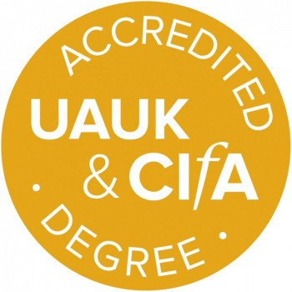
Departments can use the accredited degree logo to promote their accredited courses, which will be provided in a suitable digital format by CIfA.

6.2 Benefits for Students
Students on accredited degrees (or accredited pathways through degrees) are eligible to receive student membership to CIfA (without journal) free of charge during their degree and for the remainder of the subscription year after graduation (CIfA subscription years run from 1 April to 31 March). Information on how to apply for this will be provided to departments on successful accreditation which they should share with students. Students will apply directly for their membership through a webform.

Following graduation from an accredited degree programme/pathway, graduates should meet the criteria for Practitioner grade membership of CIfA (PCIfA). A specific competency matrix has been developed to assist graduates from accredited degree programmes making their professional membership application for Practitioner Grade.

We encourage departments to spend time helping students understand how to make an application for professional membership; including advice on how to collect and present relevant evidence.

Maintaining Accreditation and Re-Accreditation
Accreditation lasts for five years. After this point courses/pathways will need to undergo a re-accreditation, which incorporates a paperwork assessment and a site visit. For re-accreditation applications, departments will be supplied with copies of their previous NOS mapping documents which can be edited to reflect any changes since the previous application. Where modules have been revised, applicants must ensure that they are still delivering competence against the mandatory and optional NOS criteria. If modules previously mapped are no longer delivered, new mapping exercises must be completed for any new modules required to demonstrate the standard. Departments may wish to include additional modules for which new mapping documents must be supplied. All other supporting documentation listed in 5.4 should be updated as necessary.

Departments are strongly encouraged to contact Anna Welch anna.welch@archaeologists.net at an early stage to discuss their reapplication and any remapping or new mapping that may be required.

Fees for re-accreditation are as for new applications.

During the 5 year accreditation it is the responsibility of the department to update CIfA of any changes to programmes/pathways that will have bearing on the original application criteria.

Minor changes, such as changes to module or unit titles, should have no impact on accreditation status; whereas major changes, such as removal or replacement of core modules, may call for an early-re-accreditation meeting.

A pro-forma is available that departments should submit on an annual basis noting any changes to programmes/pathways and how this may impact on the original areas assessed against National Occupational Standards.

Appendix 1: Summary of Standards to be achieved

Mandatory Standards

Research and analyse information to achieve objectives (NOS AC1)
This standard is for archaeologists who undertake research. It covers both researchers conducting research they have proposed, either alone or as principal investigators at the head of research teams, and researchers working as members of those teams. A research project involves the collection and analysis of information and the timely reporting of the results. This standard includes identifying sources of information, what problems may be encountered, collecting the information to meet the needs of the research, ensuring that the information is recorded and stored correctly, recording, storing and analysing information using appropriate methods, and identifying and communicating the results of the research. Within the University context this is likely to be fulfilled by the teaching of research methods and the completion of a dissertation.

Contribute to health and safety in the workplace (NOS AH10)
This standard is designed for the archaeologist to demonstrate competence to contribute to health and safety in the workplace. It asks them to be on the look out for hazards and, when identified, deal with them if appropriate, ensuring they are reported for others to become aware of. They must be aware of their responsibilities in respect of Health and Safety at Work and the practices and procedures that help to maintain H&S for themselves and others. They would be expected to have a basic understanding of emergency services and procedures and be able to respond appropriately. Similarly, there would be a requirement to assist with security procedures with regard to trespassing and breaches of security involving damage or theft of plant, equipment, materials and property. Within the University context this is likely to be fulfilled by Professional Practice and fieldwork modules, but could easily be integrated into other modules.

Ethical framework and personal development (NOS AJ3)
This standard is about developing a student’s own knowledge and skills and managing your time and other resources so that you can meet your objectives. In order to develop yourself to improve your performance, you need to assess your current performance, identify, plan and take action to meet your development needs. You also need to update your development plans in the light of your improved performance and changing circumstances. To manage your own time and resources to meet your objectives, you need to agree and prioritise your objectives, plan your time, delegate responsibilities to others, take decisions, and review and reschedule your activities as appropriate. To protect the interests of others you need to be fully aware of the legal and ethical standards that apply to archaeological practice and of your own responsibilities as a professional practitioner. This standard is likely to be achieved via a range of modules, including, but not limited to, study and research skills. PDP and CPD are a key component of this standard.

Five most commonly selected Optional Standards

Non-intrusive archaeological investigations (NOS AC3)
This standard involves making contributions to non-intrusive archaeological field investigations (primarily various types of surveys). The standard is for archaeology students working under the direction of a more senior archaeologist who will be responsible for carrying out the field investigation. This standard deals with the contributions to preparation for an investigation, the fieldwork and the recording and storing of the data. This would be delivered via a specialist survey or geophysics module.

The analysis and interpretation of archaeological material and data NOS AC8)
This standard is for archaeologists who undertake the analysis and interpretation of archaeological material and data. This work may be undertaken as part of a research project or be guided by a research framework but it is also relevant to any other circumstances where analysis and interpretation of archaeological material and data are required. It will cover data sets such as primary excavation records or SMR records and materials including historic documents, artefacts, human remains, animal remains and palaeoenvironmental assemblages. In the University setting this standard would typically be achieved via specialist modules which studied primary excavation records, SMR records, historic documents, artefacts, human remains, animal remains or palaeoenvironmental assemblages

Intrusive archaeological investigations (NOS AC5)
This standard involves making contributions to intrusive archaeological field investigations ranging from surface artefact collection to excavation. The standard is for archaeology students working under the direction of a more senior archaeologist who will be responsible for carrying out the field investigation. This standard deals with the contributions to preparation for an investigation, the fieldwork and the analysis and presentation of the data. This would be delivered via fieldwork modules.

Routine interventive conservation procedures (NOS AD8)
This standard is for archaeological conservators or conservation technicians, people who are required to have knowledge of a range of items or specific groups of items and the potential conservation problems that may be encountered by such items. Once a conservation option has been selected it has to be implemented. One type of option is for the application of routine interventive conservation. This could involve a range of routine interventive procedures depending on the condition of an item, and type of action being agreed by the owner or keeper. This standard covers minimising deterioration in the item by implementing routine interventive stabilisation procedures and routine cleaning and repair. This would be delivered via conservation modules.

The identification and evaluation of the requirements of users of exhibitions or interpretative activities (NOS AG3)
This standard is for archaeologists who have responsibility for exhibitions and interpretative activities. It is important to identify and evaluate the requirements of users of learning and interpretative activities. This involves identifying current and potential users, both as individuals and in groups, and their learning, educational and social needs. It also involves gathering information through suitable collection methods and from all relevant sources and consulting representative groups of users to determine their current and future needs. This information needs to be analysed and related to the organisation's learning strategy. The impact of interpretative and learning activities on users needs to be evaluated. This involves using information from a variety of sources such as surveys, admissions data and knowledge and observations of staff. This information needs to be analysed and recorded so that the feedback can be used to influence the strategy for interpretation and to revise the evaluation activity. Interpretative Activities - these can take a number of forms and involve creating visual or multi-media scenarios that assist the public in understanding the historic environment. A ‘son et lumière' event could be one such interpretive activity. Within the University sector this would be delivered via heritage modules or modules on museum exhibitions.

Appendix 2: Example Mapping Matrix document

Below are some examples of how you might want to complete the matrix mapping documents.

Research and analyse information to achieve objectives (NOS AC1)
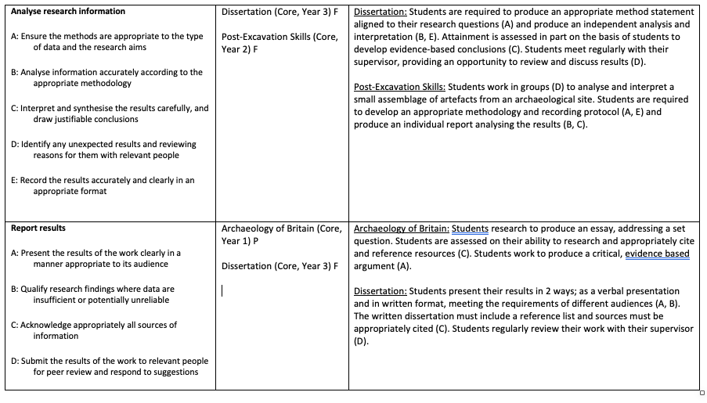

Contribute to health and safety in the workplace (NOS AH10)

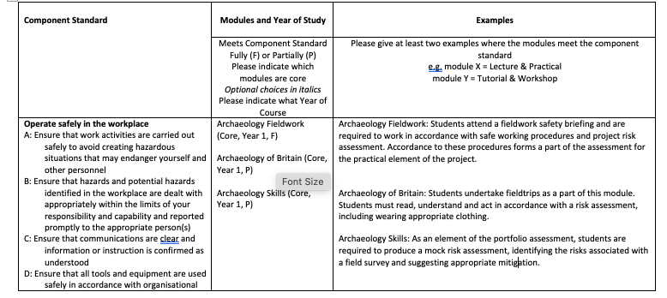

Intrusive archaeological investigations (NOS AC5)
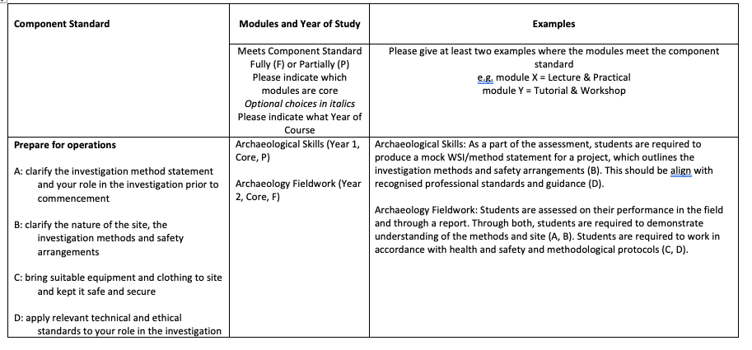

PCIfA is one of CIfA’s three professionally accredited member grades – the others being Associate (ACIfA) and Member (MCIfA). You can find out more information about this on the CIfA website.

