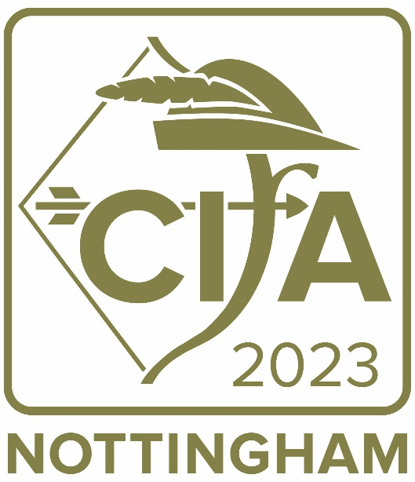

Annual conference and training event

19-21 April 2023

About CIfA2023
CIfA is delighted to announce that the CIfA2023 conference will be held from Wednesday, 19 April - Friday, 21 April 2023.

CIfA2023 will be hosted live in Nottingham UK and streamed online. We hope this will offer attendees the same flexibility as our 2022 conference but learning from our experiences to allow for the best digital user experience.

CIfA2023 will incorporate keynote addresses, wide-ranging sessions and training workshops in a live and virtual forum. Across the conference, we will discuss current professional issues, showcase new developments, and present research in archaeology and the wider heritage sector. Our conference is the premier professional archaeological conference in the UK, attracting hundreds of participants across the heritage environment sector.
Draft conference programme with confirmed sessions
The following draft conference programme details the sessions that have been confirmed for CIfA2023.
Call for papers
These sessions are actively accepting and calling for papers and would welcome submissions from individuals, groups or organisations who may be interested in contributing to the session at CIfA2023.
We want these to showcase great archaeology, to stimulate debate, and to look to change how we work and how we promote our profession to others.

We intend to record all presentations (barring a few exceptions) delivered at CIfA2023 and to livestream presentations delivered in person to our digital attendees. All session recordings will be made available for our attendees to view on demand from the online conference platform.

Each session is provided two complimentary places at conference. These are generally reserved for session organisers for the time invested. Beyond those two places, speakers will be asked to pay £40 for the day they are speaking. This is to cover costs such as lunch, beverages throughout the day, as well as a portion of the day’s venue hire. If this fee is prohibitive for your attendance, there will be several bursaries available, including a speaker-specific bursary pool, which can assist with registration costs, travel costs, or care costs. Your ability to cover these costs will not impact paper selection.
To submit a proposal for a paper:
- complete the Microsoft Forms here
- if you are unable to complete the Microsoft Form, please
  - email the conference@archaeologists.net with the title of your paper and an abstract of up to 150 words
  - make sure you include your name and contact details in your submission
  - advise if you have any additional requirements, needs, or may need any logistical support
  - confirm your availability to deliver online or attend in person on the date/time of the session as per our draft timetable

In the interest of promoting a more varied set of speakers, this year we will ask speakers to present papers at a maximum of two sessions. If you are offered the opportunity to speak at three or more sessions, you will need to select two. We hope this will give more opportunities to present for early careers archaeologists and those who may not have been selected to present in previous years.

The deadline for the submission of papers is
13 January 2023

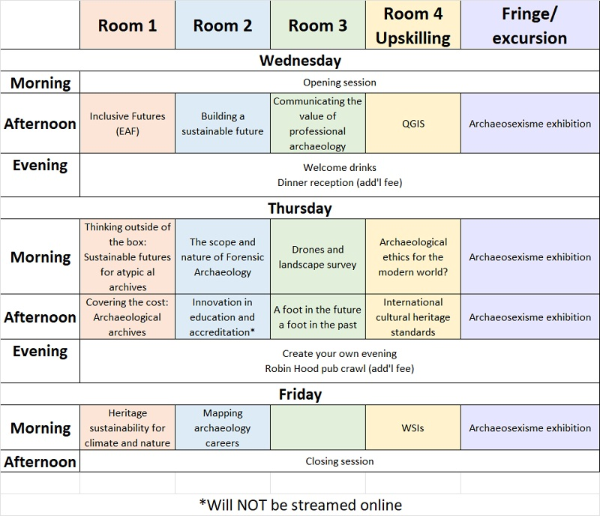
The following sessions are not asking for papers in this call:
- Communicating the value of professional archaeology
- QGIS
- WSIs

Inclusive Futures (EAF)
Wednesday, 19 April: 14:00 – 17:30
Organiser(s): Emily Stammitti, Abigail Hunt, Enabled Archaeology Foundation

In order to better serve our communities and many commercial interests, the EAF proposes this session, Inclusive Futures, to highlight great inclusive case studies from around the country, from commercial sites to community festivals. We hope that this session will provide a platform through which all members of the archaeological and heritage community (E.g., practitioners, students, community members and academics) in enabling and inclusive practice can offer up the means through which we can all better learn how to transcend the world of good ideas and turn them into active, inclusive realities for all. All studies and practices in which ideas meet action, sites meet accessibility, social impact meets social justice, and where calls for equality meet enablement are welcome proposals. While a series of presentations will form the basis for this session, we will have a short break and conclude with a lengthy panel discussion - open to all.

Building a sustainable future
Wednesday, 19 April: 14:00 – 17:30
Organiser(s): Kate Geary

This session will invite keynote speakers and conference delegates to set out their vision of a sustainable future for archaeology from a range of perspectives, with themes including skills development and career pathways, inclusion and accessibility, professionalism and ethical practice, quality standards and regulations, value and public benefit. Delegates will then break out into facilitated working groups to consider what needs to happen for the vision to be achieved, using theory of change/logic modelling. Finally, a plenary session will draw together conclusions, identify links with existing strategies and initiatives and identify where new approaches may be needed.

Thinking outside of the box: sustainable futures for atypical archives
Thursday, 20 April: 09:30 – 13:00
Organiser(s): Helen Parslow, David Ingham, Manda Forster

The standards and skills involved in producing site archaeological archives have improved in the past decade, with both physical and digital archives being managed to a higher standard and becoming more accessible with better information and increased deposition. Looking beyond traditional archaeological archives, we are interested in how established standards, skills and stores which support archive generation apply to more atypical archives. Are the same skills required to produce them? Are they managed in the same way and to the same standards? And is the current infrastructure able to make sure they are accessible well into the future?

This session will consider how existing standards and guidance for creating archaeological archives are applicable to the more atypical archive. What sort of archives are being produced and what sort of future proofing is built into them? Are physical archives being generated, and where are these being kept – if not in a museum, are they accessible? Where archives are mainly digital, how and where are these being deposited? Are we considering how researchers, educators or museums are accessing and using archives? Or have you benefitted from archives being more findable or accessible?

Join us to help the sector think outside of the box… We’re looking for talks relating to activities such as (but not restricted to) building surveys, geophysics, maritime archaeology, environmental samples, digital assets, community projects and university research, as well as looking at legacy archives…

The scope and nature of Forensic Archaeology
Thursday, 20 April: 09:30 – 13:00
Organiser(s): Robert Janaway, Laura Evis, CIfA Forensic Archaeology Special Interest Group

The definition of what is (and importantly what is not) forensic archaeology is varied. In England and Wales, under auspices of the Home Office Forensic Science Regulator this is clear (see CIfA standards and Guidance for Forensic Archaeologists) but recently this has been thrown into sharp relief with the recent investigations on Saddleworth Moor (see CIfA statement 14/10/22)

The aim of this session is to present a range of different viewpoints regarding the nature and definition of forensic archaeology both from the UK but also internationally. We will examine the archaeological role both in both practice but also regulatory and legal constraints for following areas:
a) Police investigations (search and recovery of clandestine graves)
b) Licenced exhumations
c) Post-conflict recovery of human remains (historical and not related to war crimes)
d) Post-conflict as part of war crime investigation (including summary of current situation in Ukraine).
e) Archaeological role in mass fatality incidents (Disaster Victim Identification)

The session will consist of a series of short presentations from invited speakers but will use these as a springboard for a wider debate from the audience.
Drones and landscape survey: balancing imagery and interpretation
Thursday, 20 April: 09:30 – 13:00
Organiser(s): David Went and Olaf Bayer

The archaeologist’s ability to model and visualise archaeological landscapes and earthworks has leapt forward in recent years. Extensive accessible lidar coverage in the UK, ‘Structure from Motion’ applications for aerial photography and now drone-acquired lidar, enable us to produce engaging and informative topographical models with increasing ease and versatility. Historic England’s archaeologists are among many in the sector who have been working with drone-derived digital imagery for more than a decade and seeking ways to embrace these models within the much longer tradition of earthwork survey. This session will bring together leading practitioners to compare approaches and, in particular, the issues of analysis and interpretation which extend far beyond depiction, however sophisticated modern digital depictions might be. The aim is to share knowledge and to initiate a conversation leading toward agreed professional standards at this key stage in the development of these emerging techniques.
Archaeological ethics for the modern world?
Thursday, 20 April: 09:30 – 13:00
Organiser(s): Peter Hinton

At CIfA 2022 we considered whether CIfA should review its Code of conduct, and the profession answered 'yes'. This session will report on the work to date and invite critique of what we have now and of the thinking so far and how the Code might change to reflect today's ethics and to be globally applicable.

Covering the cost: archaeological archives
Thursday, 20 April: 14:00 – 17:30
Organiser(s): Samantha Paul and Manda Forster

The success of development-led archaeology since the early 1990s has led to a major increase in the quantity of archaeological material in museum stores across the country and many museums are becoming unable to accept new finds. Recent research projects commissioned by Historic England and Arts Council England have aimed to understand how the museum and wider archaeological sector can be best supported in developing a sustainable model which provides the needed capacity for existing and future archaeological archives.

In 2021 the Options for Sustainable Archaeological Archives (OSAA) project made recommendations for the creation of a National Collection of Archaeological Archives (NCAA) underpinned by a robust and sustainable costing model (link to report to be added). In 2018, the value of developer funded archaeological fieldwork was estimated to be £245m per annum. The OSAA project recommendations suggested a new model for archives which guaranteed the accessioning of all projects but highlighted the need for this approach to be supported by a sustainable cost model unlikely to be met by that currently practiced, which is based on a deposition charge for individual projects.

The implementation of a new costing model would impact all stages within planning led archaeology – from the initial costing and tender processes, through to selection, deposition and accessioning of the final project archive. The feasibility of alternative cost models and implications for the sector are being investigated through a new project funded by HE: the Options Appraisal for Costing Models for the Transfer of Archaeological Archives. All options considered will need to be carefully balanced to cover the requirements of all projects and will have to consider all archive elements.

This session will present the initial findings from a data collection phase of the project, exploring the potential impacts of cost models using real-world project examples in order to explore the sustainability of potential costing structures. Session attendees will be asked to take a closer look at the proposed cost models, helping to stress test and assess each scenario and provide feedback into the overall project results. The session therefore provides a key moment for those interested in the future of archaeological archives to contribute to new models which will impact the sector.

Following the session and further sector wide consultation, it is hoped the report will produce a framework and recommendations for cost models which will ensure that a sustainable and realistic mechanism for calculating the costs of archive deposition that both reflects their importance as a resource for future research and the scale of the projects that produce those archives.

Innovation in education and accreditation
Thursday, 20 April: 14:00 – 17:30
Organiser(s): Ben Jennings
NOTE: This session will not be streamed online

With a number of higher education institutions having successful achieved CIfA / UAUK accreditation for degree programmes in the UK, this session seeks to bring together member from provisioning institutions to discuss innovative developments in the delivery of degree programmes. Members are invited to share experiences of the accreditation process and innovations in teaching practice as a result of degree accreditation and other higher education sector demands.

A Foot in the Future and a Foot in the Past: Pushing practice and leaving a sustainable legacy
Thursday, 20 April: 14:00 – 17:30
Organiser(s): Emily Plunkett, Helen Wass, Naomi Trott, Adam Fraser

NPPF states that heritage is an irreplaceable resource which should be conserved “so that they can be enjoyed for their contribution to the quality of life of existing and future generations”.

Taking inspiration from CIfA 2022; we need to achieve sustainable heritage and a sustainable industry. To do this we need to employ a range of techniques to:
• Tell the stories of the people we engage with;
• Create knowledge not data;
• Communicate our findings;
• Innovate; and
• Up skill.

We need to use these techniques to ensure what we do is accessible, compelling, and informative. This will ensure we demonstrate our value and create a sustainable industry.

This session invites papers which consider:
• applying new practice or approaches;
• applying existing practice in new ways;
• Lessons learnt;
• The future of practice, standards, or guidance; and
• How our industry and heritage remain sustainable and able to be defended or maintained into the future.

International cultural heritage: applying professional standards and skills in challenging environments
Thursday, 20 April: 14:00 – 17:30
Organiser(s): Leonora O’Brien

This session will provide a forum for discussing the practical, personal and regulatory challenges of working on archaeology and cultural heritage projects around the world, sometimes in physically or culturally challenging environments. The organisers would welcome presentations discussing colleagues’ experiences of collaborating on heritage projects, working together with local partners and sharing skills. The session will seek to identify common challenges, myths and innovative approaches to successfully delivering projects and furthering professional practice.

Heritage sustainability for climate and nature
Friday, 21 April: 09:30 – 13:00
Organiser(s): Hannah Fluck, National Trust and Alex Llewellyn, CIfA

We are facing a climate and biodiversity crisis and societies responses to this are being played out across the landscape, from urban to rural. This session will explore the relationship between the historic environment, land management, biodiversity and climate gain, and how decisions to deliver the necessary responses for climate and nature are affecting, and could be influenced by, our cultural heritage. This will be a round table discussion with speakers including local authority, commercial and ngo archaeologists, built environment experts and representatives from other environmental sectors such as ecology and water management. Speakers will share examples of projects which are successfully creating sustainable places for heritage as well as nature and climate with plans to deliver targets, and the tools and/or approaches that can be used. Each speaker will speak for 5 minutes and pose a question, challenge or suggestion for what net carbon zero actually looks like or means which will be picked up in a round table discussion.

Mapping Archaeological Careers
Friday, 21 April: 09:30 – 13:00
Organiser(s): Jessica Elleray and Phil Pollard, Historic England

Following on from our 2021 session Journeys into an archaeological career, this interactive workshop will bring together speakers from a number of different roles and specialisms within archaeology and attempt to visually ‘map’ the career paths that got these people to the position they are now in. We will then identify the similarities and differences between the different paths and discuss how others could follow this, and where barriers to these paths may exist today.

We are looking for speakers who are willing to share their career journeys, to draw them up live during the workshop and to be asked questions. We are not looking for pre-prepared presentations, though coming with thoughts and notes to discuss and inform the mapping would be welcome. We will also ask speakers to facilitate and support participants to write up their career maps during the workshop, to help identify next steps and to be on hand to offer careers advice.

