MINUTES OF THE ANNUAL GENERAL MEETING OF THE CIfA FINDS SPECIAL INTEREST GROUP

Held: Thursday 1st December, 2022
Mortimer and Wheeler House and on Zoom

Attendees: Emily Johnson (EJ; Chair), Bekky Hillman (BH; secretary), Imogen Wood (IW, Treasurer), Nicky Rogers (NR), Megan Keates (MK), Mags Felter (MF)

IW welcomed everyone to the meeting and thanked everyone for attending.

1. Apologies

Peter Guest, Helen Wickstead

2. Minutes of Previous AGM and matters arising

The Minutes of the previous AGM were accepted as a true record (proposed by BH and Seconded by EJ, all were in favour) and there were no matters arising.

3. Election of committee members

Stepping down:
Mags Felter (Secretary)
Mags got a huge thank you for all her hard work on the committee over the years especially over lockdown for arranging all Zoom meetings and covering most of the Chair work over the last year. Mags will stay on as a member in an advisory capacity with no voting rights.

Stepping up
Emily Johnson applied to step up to Chair (Nomination proposed by MF and seconded by BH and NR)
Bekky Hillman applied to step up to Secretary (Nomination proposed by EJ and seconded by NR and Nigel Page

Anna Tyacke applied to join the committee as an ordinary member (Nomination proposed by IW and seconded by MF and BH

Current committee:
Ordinary members Nicky Rogers and Helen Wickstead and Treasurer: Imogen Wood co-opted again this year.

All were uncontested. The membership present were asked to vote in person and via digital poll and the changes were unanimously voted in.

4. Chair’s Report (given by Imogen Wood)

- Having been without a Chair this year progress has been limited
- Group activities and plans for 2022 still impacted by Corona virus situation
- Proposed CIFA conference session for 2023 was not accepted
- The Roman Coin Toolkit is now live online
- Emily attended Advisory council and reported back on updates to fieldwork standards and guidance and developments in equality, diversity and inclusion best practice.
- The committee plans to review our practice in terms of equality diversity and inclusion to make sure we’re serving as many Finds practitioners etc as we can.

5. Treasurer’s Report (given by Imogen Wood)

- Only funds used this year was the budget of £300 for the conference, which was not adequate and we exceeded the budget.
- A larger budget request will be put in to CIfA for the coming year with travel expenses having risen dramatically over the past few years.

6. Secretary’s Report (given by Imogen Wood)

2 committee meetings since last AGM:
4th February 2022
16th June 2022

Mags acts as representative of ICON Archaeology Group

7. Communication Officers report (given by Emily Johnson)

- Twitter account still active but interactions are not good; not the way to communicate
- Second social media platform option was put to the members so that they could choose which platform they would perfer. Respondants favoured Facebook and Instagram.
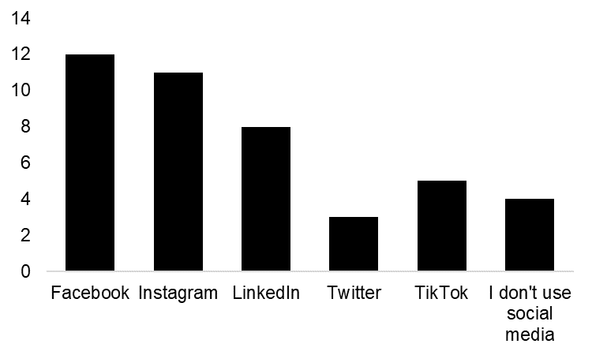
Participants (n=21) responding to What social media platforms do you use?

- From Spring 2023 the bi-annual newsletter will be brought back with a bulletin of finds group news and CPD advice
- The webpage will be overhauled as it is out of date and not very user friendly

8. Three Year Plan outline and approval

The new three year plan was proposed by EJ and seconded by IW. The membership present were asked to vote in person and the plan was unanimously accepted.

Outline was discussed and approved, collaboration with archives group also to be added

9. Questions from members

No questions were raised.
The results of our mini survey asking “What one thing would you like to see the Finds group do/ do better?” were:
- Increase awareness about the Finds group generally amongst archaeologists
- Unusual materials
- Links to workshops and training
- I am just joining today so hope to help with my experience and knowledge
- Be more active
- Some more specialist training days
- You mean it isn't perfect? A bit more communication maybe, to share questions etc
- Perhaps more formal liaisons with other finds groups such as Finds Research Group, pottery groups etc. to see what they are doing
- Finds group exhibition
- Waterlogged wood
- Sea shells
- Promote specialist apprenticeships/mentoring in the workplace
- Training events (CPD) throughout the year to support the development of entry level/junior specialists. This could be in person, online or recorded workshops.

10. AOB
IW proposed that a later start and finish times for future events would make attendance easier and avoid the costs of peak time travel

B. Hillman
13.12.2022

