Chartered Institute for Archaeologists
Equality, Diversity and Inclusion (EDI) committee member role and responsibilities and nomination statement

Introduction
The Chartered Institute for Archaeologists (CIfA) is governed by its Royal Charter, by-laws and regulations. The affairs of CIfA are managed by the Board of Directors which has legal responsibility for CIfA. The day to day running of CIfA carried out by the staff. An Advisory Council provides advice to the Board of Directors on policy matters and the long-term strategy of CIfA.

Committees
Under the regulations of CIfA, the Board of Directors has the option to delegate its authority to committees. The name, membership and terms of reference for each committee and the manner in which committee meetings are conducted shall be determined by the Board of Directors.

The Board delegates authority for the Validation Committee, Registrations Committee (Organisations) and Degree Accreditation Committee to assess applications for accreditation. The Board has an EDI committee to support its work in delivering a strategy for equality, diversity and inclusion.

The regulations for these committees are available on the CIfA website at https://www.archaeologists.net/codes/cifa. The EDI committee is governed by the Regulations for the EDI committee.

The role EDI committee member
Responsible to CIfA Board
Responsibilities to support the Board of Directors in delivering a strategy for equality, diversity and inclusion.
Commitment a minimum of 4 days per year
Term 3 years
Remuneration Travel and expenses only

Committee membership
The EDI committee will have a maximum of seven individuals and will ideally include
- the nominated Board EDI champion
- up to five accredited members (PCIfA, ACIfA, MCIfA)
- one accredited or non-accredited member who is an early career archaeologist
- one accredited or non-accredited member who is from the Global Majority

The current vacancy is for an accredited member of the Institute.

Term of office
Committee members are appointed by the Board of Directors for a three-year term. The maximum consecutive term of office will be two consecutive three-year terms.

Conflicts of interest
Members of committees are expected to declare any conflicts of interest they may have when considering an application and to withdraw from the discussion

Expenses
Committee members will be reimbursed for expenses incurred in the pursuit of their duties as set out in the expense guidance.

Person specification
Essential |  | Desirable
Attributes | - a collaborative and supportive working style, with respect for others’ viewpoints and understandings  - cultural sensitivity  - an ability to build relationships with key stakeholders  - accept of the seven principles (Nolan’s principles see appendix 1) of public life: selflessness, integrity, objectivity, accountability, openness, honesty and leadership
Knowledge | - an interest in and commitment to promoting equality, diversity and inclusion  - familiarity with issues relating to equality, diversity and inclusion in archaeology | Knowledge | - have an understanding of the work and strategic direction of CIfA
Qualifications | - CIfA Accreditation (PCIfA, ACIfA, MCIfA) | Qualifications | - Membership of other relevant organisations
Experience |  | Experience | - Prior committee work

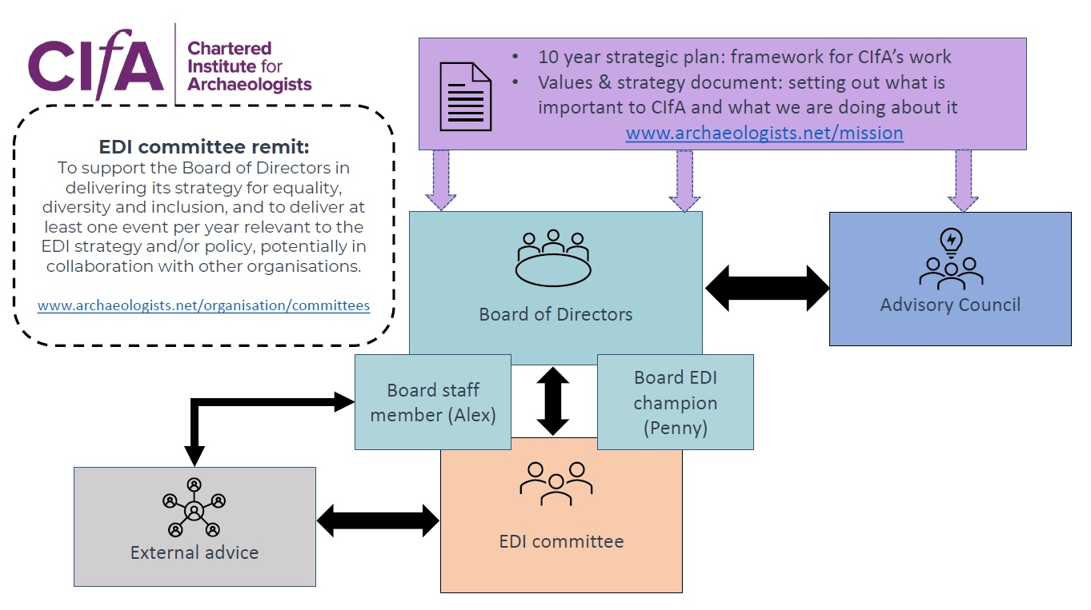
Please explain why you are interested in being elected to the EDI committee (max 250 words)

What skills and experience do you have that are relevant to being a member of the EDI committee (please refer to the above person specification) (max 250 words)

CIfA Committee members declaration

I, the undersigned, declare that:
- I have read, understood and will work to the responsibilities and attributes in the person specification.

- I will treat all information, documentation etc that I have access to as part of my duties on the committee in the strictest confidence and not discuss or disclose these with third parties until I understand that it is acceptable to do so.

- I have read the CIfA regulations and guidance for the relevant committee

Signed
Name
Date
CIfA membership | ☐MCIfA ☐ACIfA ☐PCIfA
Membership number
Contact email
Attachments | CV ☐  CPD log ☐

Appendix 1: Guidance
The Nolan Principles
(1995, First report of the committee of standards in public life)

- Selflessness | Holders of public office should take decisions solely in terms of the public interest. They should not do so to gain financial or other material benefits for themselves, their family or friends
- Integrity | Holders of public office should not place themselves under financial or other obligation to outside individuals or organisations that might influence them in the performance of their duties
- Objectivity | In carrying out public business, including making appointments, awarding contracts, or recommending individuals for rewards or benefits, holders of public office should make choices on merit
- Accountability | Holders of public office are accountable for their decisions and must submit themselves to whatever scrutiny is appropriate to their office
- Openness | Holders of public office should be as open as possible about all the decisions and actions that they take. They should give reasons for their decisions and restrict information only when the wider interest demands
- Honesty | Holders of public office have a duty to declare any private interests relating to their duties and to take steps to resolve any conflicts in a way that protects the public interest
- Leadership | Holders of public office should promote and support these principles by leadership and example

Appendix 2: Policy
POLICY ON THE USE OF AI RECORDING IN CIFA MEETINGS
- The Board of Directors has agreed a policy that the use of AI technology, transcription or sound recording of CIfA committee meetings (including the Board of Directors, Advisory Council and any committee or working group established to support the work of the Board) by committee members or other attendees is not permitted due to concerns about breaches to GDPR, security of information, and the creation of unagreed documented records.

- CIfA staff or a nominated individual on behalf of CIfA attend CIfA meetings to produce a draft record of a meeting in the form of written minutes. These minutes are then approved by the committee and become a formal record of the discussions and decisions made.

- For online CIfA meetings, these are recorded where necessary by CIfA staff with the knowledge of all present. Once the minutes have been approved, recordings are deleted.

- Committee members or meeting attendees can ask for additional information or support from CIfA if they use AI to help with accessibility by contacting a member of CIfA staff.

